**Conference Room Booking Application**

**Bug Reporting**

Bug-1. **Valet parking**

Expected result- Error Massage from system display

Actual Result- attached picture

Url- <https://shino.de/parkcalc/index.php?ParkingLot=Valet&StartingDate=10%2F1%2F2024&StartingTime=12%3A00&StartingTimeAMPM=AM&LeavingDate=10%2F2%2F2024&LeavingTime=12%3A00&LeavingTimeAMPM=AM&action=calculate&Submit=Calculate>

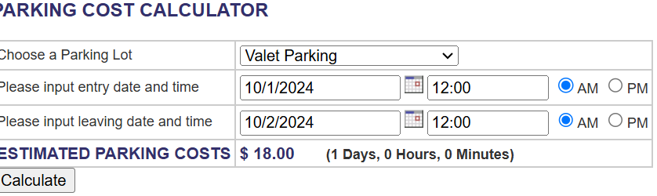

Bug-2. **Short term parking**

Expected result- Error Massage from system display

Actual Result- attached picture

URL- <https://shino.de/parkcalc/index.php?ParkingLot=Short&StartingDate=10%2F1%2F2024&StartingTime=12%3A00&StartingTimeAMPM=AM&LeavingDate=10%2F2%2F2024&LeavingTime=12%3A00&LeavingTimeAMPM=AM&action=calculate&Submit=Calculate>

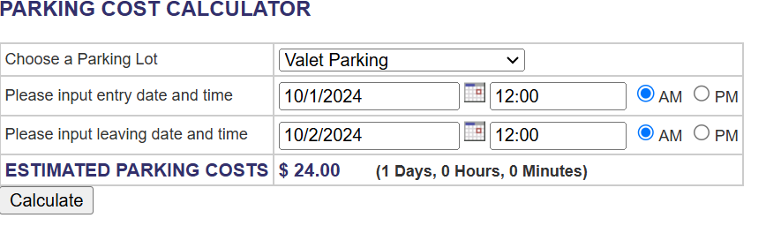

Bug-3. **Economy parking**

Expected result- Error Massage from system display

Actual Result- attached picture

URL- <https://shino.de/parkcalc/index.php?ParkingLot=Economy&StartingDate=10%2F1%2F2024&StartingTime=12%3A00&StartingTimeAMPM=AM&LeavingDate=10%2F2%2F2024&LeavingTime=12%3A00&LeavingTimeAMPM=AM&action=calculate&Submit=Calculate>

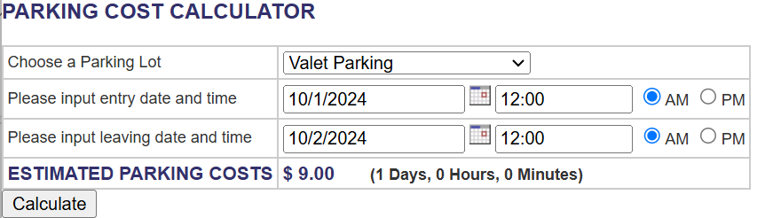

Bug-4. **Long Term garage parking**

Expected result- Error Massage from system display

Actual Result- attached picture

URL- <https://shino.de/parkcalc/index.php?ParkingLot=Economy&StartingDate=10%2F1%2F2024&StartingTime=12%3A00&StartingTimeAMPM=AM&LeavingDate=10%2F2%2F2024&LeavingTime=12%3A00&LeavingTimeAMPM=AM&action=calculate&Submit=Calculate>

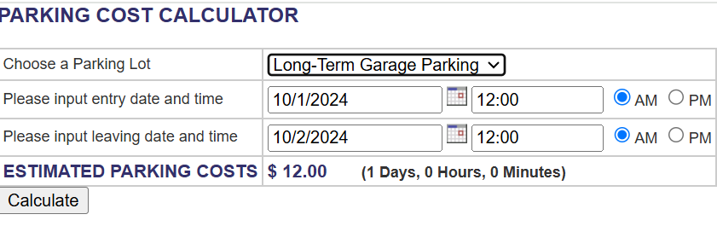

Bug-5. **Long term surface parking**

Expected result- Error Massage from system display

Actual Result- attached picture

URL- <https://shino.de/parkcalc/index.php?ParkingLot=Economy&StartingDate=10%2F1%2F2024&StartingTime=12%3A00&StartingTimeAMPM=AM&LeavingDate=10%2F2%2F2024&LeavingTime=12%3A00&LeavingTimeAMPM=AM&action=calculate&Submit=Calculate>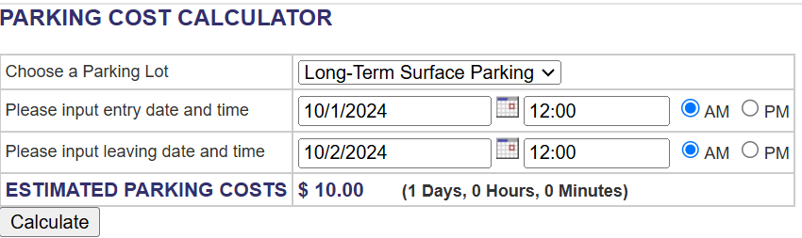

Bug-6. **Valet** **parking for 60-day 1 hour**

Expected result- 1092

Actual Result- attached picture

URL- <https://shino.de/parkcalc/index.php?ParkingLot=Valet&StartingDate=10%2F1%2F2024&StartingTime=12%3A00&StartingTimeAMPM=AM&LeavingDate=11%2F30%2F2024&LeavingTime=12%3A00&LeavingTimeAMPM=AM&action=calculate&Submit=Calculate>

Note- if the calculation process is day after day the result is okay but if the calculation starting day after hour the calculation is wrong.

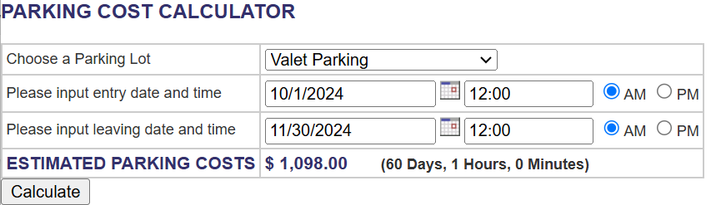

Bug-7. **Valet** **parking for 1 day 1 hour**

Expected result- 30

Actual Result- attached picture

URL- <https://shino.de/parkcalc/index.php?ParkingLot=Valet&StartingDate=10%2F25%2F2024&StartingTime=12%3A00&StartingTimeAMPM=AM&LeavingDate=10%2F26%2F2024&LeavingTime=01%3A00&LeavingTimeAMPM=AM&action=calculate&Submit=Calculate>

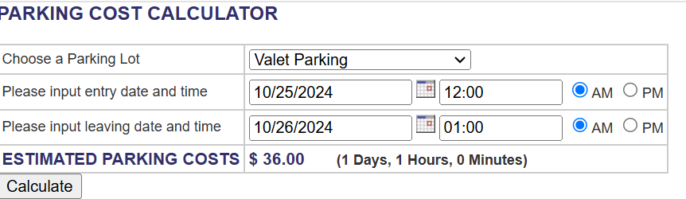Note- if the calculation process is day after day the result is okay but if the calculation starting day after hour the calculation is wrong.

Bug-8. **Valet** **parking for 0-day 0 hour**

Expected result- 00

Actual Result- $12 attached picture

URL- <https://shino.de/parkcalc/index.php?ParkingLot=Valet&StartingDate=10%2F25%2F2024&StartingTime=00%3A00&StartingTimeAMPM=AM&LeavingDate=10%2F25%2F2024&LeavingTime=00%3A00&LeavingTimeAMPM=AM&action=calculate&Submit=Calculate>

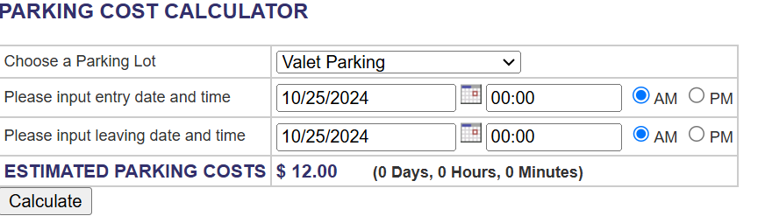

Bug-9. **Short-term parking for 0-day 0 hour**

Expected result- 00

Actual Result- $2 attached picture

URL- <https://shino.de/parkcalc/index.php?ParkingLot=Short&StartingDate=10%2F25%2F2024&StartingTime=00%3A00&StartingTimeAMPM=AM&LeavingDate=10%2F25%2F2024&LeavingTime=00%3A00&LeavingTimeAMPM=AM&action=calculate&Submit=Calculate>

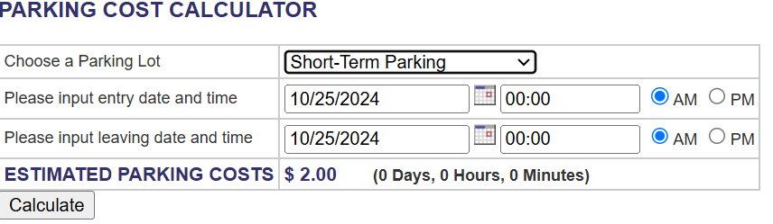

Bug-10. **Short-term parking for 1.30 hour**

Expected result- 3

Actual Result- $12 attached picture

URL- <https://shino.de/parkcalc/index.php?ParkingLot=Valet&StartingDate=10%2F25%2F2024&StartingTime=00%3A00&StartingTimeAMPM=AM&LeavingDate=10%2F25%2F2024&LeavingTime=01%3A30&LeavingTimeAMPM=AM&action=calculate&Submit=Calculate>

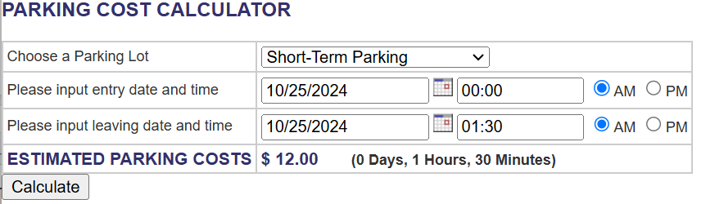

Bug-11. **Long-term Garage parking for 7 days 1 hour**

Expected result- Error massage shown from system display

Actual Result- $144 attached picture

URL- <https://shino.de/parkcalc/index.php?ParkingLot=Valet&StartingDate=10%2F25%2F2024&StartingTime=12%3A00&StartingTimeAMPM=AM&LeavingDate=10%2F31%2F2024&LeavingTime=24%3A00&LeavingTimeAMPM=AM&action=calculate&Submit=Calculate>

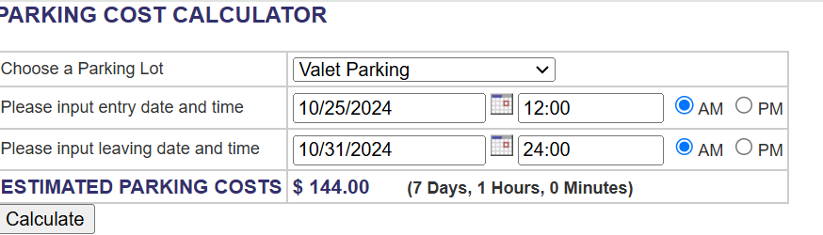Bug-Bug-12. **Long-term Surface parking for 7 days 1 hour**

Expected result- Error massage shown from system display

Actual Result- $62 attached picture

URL- <https://shino.de/parkcalc/index.php?ParkingLot=Economy&StartingDate=10%2F25%2F2024&StartingTime=12%3A00&StartingTimeAMPM=AM&LeavingDate=10%2F31%2F2024&LeavingTime=24%3A00&LeavingTimeAMPM=AM&action=calculate&Submit=Calculate>

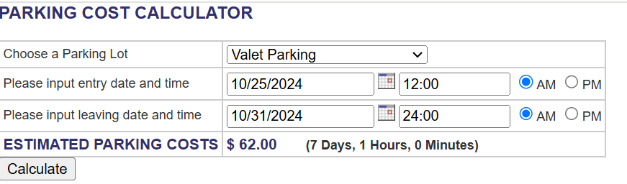

Bug-13. **Economy Surface parking for 7 days 1 hour**

Expected result- Error massage shown from system display

Actual Result- $56 attached picture

URL- <https://shino.de/parkcalc/index.php?ParkingLot=Economy&StartingDate=10%2F25%2F2024&StartingTime=12%3A00&StartingTimeAMPM=AM&LeavingDate=10%2F31%2F2024&LeavingTime=24%3A00&LeavingTimeAMPM=AM&action=calculate&Submit=Calculate> 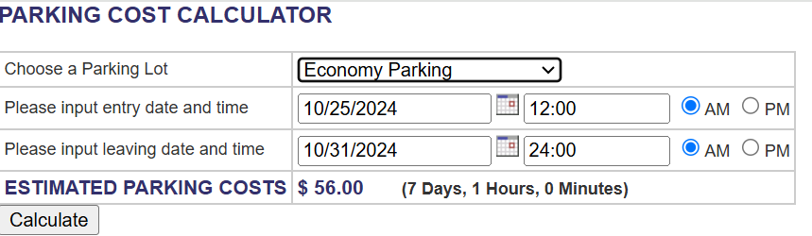.

Bug-14. Calendar shown outside of device Samsung galaxy S8+

Chrome Product version: 130.0.6723.70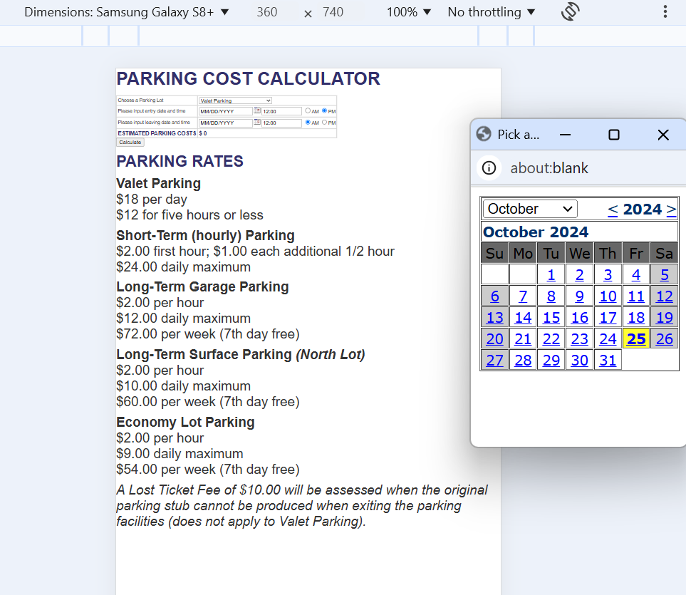

.

Bug-15. **Large Room booking for 7 days**

Expected cost- $11200

Result- Booking ID: 28. Room: Large Room, Start Time: 10/22/2024, 1:00:00 PM, End Time: 10/29/2024, 1:00:00 PM, Final Cost: $78400.

Booking ID: 28 has been cancelled. A cancellation fee of $39200 will be applied.

Bug-16. **Large Room booking for 7 days 1 hour**

Expected cost- $11400.

Result- Booking ID: 29. Room: Large Room, Start Time: 10/22/2024, 1:00:00 PM, End Time: 10/29/2024, 2:00:00 PM, Final Cost: $78400.

Booking ID: 28 has been cancelled. A cancellation fee of $39200 will be applied.

Bug-17. **Executive Room booking for 1 days 1 hour**

Expected cost- $2700.

Result- Booking ID: 33. Room: Executive Room, Start Time: 10/22/2024, 1:00:00 PM, End Time: 10/23/2024, 2:00:00 PM, Final Cost: $16800.

Booking ID: 33 has been cancelled. A cancellation fee of $8400 will be applied.

Bug-18. **Executive Room booking for 3 days**

Expected cost- $7200.

Result- Booking ID: 34. Room: Executive Room, Start Time: 10/22/2024, 1:00:00 PM, End Time: 10/25/2024, 1:00:00 PM, Final Cost: $50400.

Booking ID: 34 has been cancelled. A cancellation fee of $25200 will be applied.

Bug-19. **Executive Room booking for 3 days 1 hour**

Expected cost- $16800.

Result- Booking ID: 35. Room: Executive Room, Start Time: 10/22/2024, 1:00:00 PM, End Time: 10/25/2024, 2:00:00 PM, Final Cost: $50400.

Booking ID: 35 has been cancelled. A cancellation fee of $25200 will be applied.

Bug-20. **Executive Room booking for 7 days**

Expected cost- $16800.

Result- Booking ID: 36. Room: Executive Room, Start Time: 10/22/2024, 1:00:00 PM, End Time: 10/29/2024, 1:00:00 PM, Final Cost: $117600.

Booking ID: 36 has been cancelled. A cancellation fee of $58800 will be applied.

Bug-21. **Executive Room booking for 7 days 1 hour**

Expected cost- $17100.

Result- Booking ID: 37. Room: Executive Room, Start Time: 10/22/2024, 1:00:00 PM, End Time: 10/29/2024, 2:00:00 PM, Final Cost: $117600.

Booking ID: 37 has been cancelled. A cancellation fee of $58800 will be applied.

Bug-22 Navigation testing failed

Didn’t work view **booking** and **contact us** **command**

URL - <https://muntasir101.github.io/Conference-Room-Booking/#contact> .

Bug-23. **Pages with spelling errors**

**Title: Conference Room Booking**

|  |  |
| --- | --- |
| **Page #1:** | [**https://muntasir101.github.io/Conference-Room-Booking/**](https://muntasir101.github.io/Conference-Room-Booking/) |

Bug-24. Device testing

Calendar didn’t show escape galaxy s10/s10+

Google Chrome- Version 129.0.6668.101 (Official Build) (64-bit)

Bug-25. Device testing

Display over the side(scrolling).

iPad. iPadOS 14.7.1

Google Chrome- Version 129.0.6668.101 (Official Build) (64-bit)

Bug-26. Console error

Uncaught TypeError: bookingsList is null displayBookings <https://muntasir101.github.io/Conference-Room-Booking/script.js:129>

Bug-27

Device Iphone 12 pro

Google Chrome- Version 129.0.6668.101 (Official Build) (64-bit)

